Automatic Vehicle Headlight Management System to Prevent Accidents Due To Headlight Glare

**ABSTRACT:**

The headlight during the night travel plays a major role. While driving there may be an irritating situation due to the headlight lamp focus from the opposite vehicle. It may cause temporary blindness that leads to collision or sometimes it may lead to accidents. There is a manual way to adjust the headlight focus but it is difficult to adjust manually. This paper provides an automated headlight management system. Here, the headlight beam is reduced in the vehicle according to the intensity of light from the opposite vehicle. LDR is used to detect the high beam from the opposite vehicle. Keywords: headlight, vehicle, temporary blindness, LDR.

**INTRODUCTION:**

High beam from the headlight causes a dangerous situation during night driving. It causes temporary blindness for the drivers that may lead to collision or sometimes it may lead to accident. Pedestrian crossing the road may get hurt. Almost 30% of accidents occurring due to headlight glare. When enough streetlights are available, there is no need of headlight beam with such high intensity. This project helps to automatically control the headlight glare in motor vehicles. LDR is known as light dependent resistor, its resistance varies according to the intensity of light falling on it. Microcontroller used here is arduino uno. Microcontroller controls the high beam falling on it. When a high beam falls on the surface of LDR, the information passes to the microcontroller. Microcontroller compares the intensity of incoming light with the desired intensity value. When the intensity value is increased beyond the desired intensity value, it reduces the intensity of light and provides a great relief for the driver from the irritating situation that occurs during the night driving.

**SURVEY ON ACCIDENTS DUE TO HEADLIGHT GLARE:**

More than 30% percent of accidents during night time happen due to headlight glare. The visibility during night time also reduced due to fog. The correct use of dipper (low beam) during night is essential for the drivers in the presence of street light. The unwanted use of high beam may lead to unnecessary crashes. A survey says that 26.5% alone use dipper correctly out of 73.83%, remaining 48.3% continued in high beam itself and the remaining 25.53% dipped the light for a few seconds and continued to be in a high beam. Some of the technologies that are used to control high beam of headlight are LDR based intensity control, Fuzzy logic based intensity control, wireless sensor network method, IR transmitter-receiver method, and camera based intensity control, pulse width modulation method. In this paper we used LDR based intensity control method. Almost 1,200 luminance of light intensity in case of high beam is more than enough to view the potential obstacles and also to react. But sometimes owners replace the headlight with about 2000-3000 luminance of intensity. This may lead to unavoidable crashes.

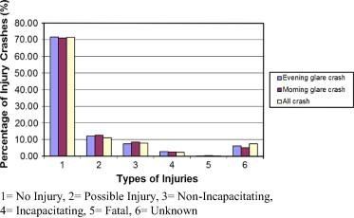

**Possibility of Glare Crash**

The above graph insists about the possibility of glare crashes, percentage of injury crahes and types of injuries that may occur due to headlight glare crash.

**BLOCK DIAGRAM:**

The following block diagram clearly explains about the proposed system.

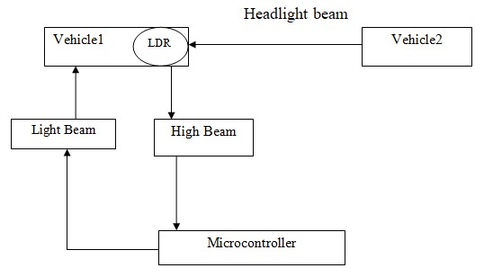

**fig Block diagram of Vehicle headlight management system.**

Most of the accidents during night occur due to the high amount of light falling on the vehicle. It cause glaring and troxler fading that leads to accident. To overcome this problem the intensity of light falling on the other vehicle should be reduced automatically. There is manual adjustment of intensity of light but it is difficult to adjust manually during some situations. To overcome this problem, automatic adjustment of light is needed which is described in this paper. LDR is used to measure the amount of intensity of light falling on the vehicle. When the LDR detects the large amount of intensity of light falling on it, the microcontroller reduces the amount intensity of light in the vehicle. This gives the clear vision for the drivers. Thus, it prevents the collision and accidents before occurring it.

**Light Dependent Resistor (LDR):**

LDR is a sensor that changes its resistance according to the amount of intensity of light falling on it. Increasing the intensity of light decreases the resistance and increases the conductivity of LDR. The output of LDR is an analog output.

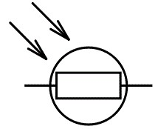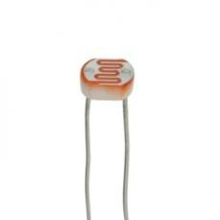

The Light Dependent resistor works on the principle of Photo conductivity i.e. the conductivity of the LDR increases by increasing the intensity of light falling on it. When the LDR is kept in dark, the resistance of it is very high that is up to 1012Ω. At the same time, when the LDR is placed in sunlight, there is a drastic fall in the resistance of LDR.

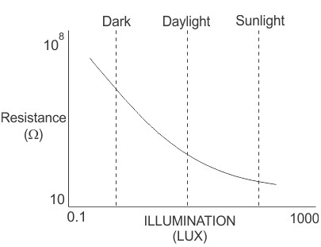

**fig 3.3.2. Characteristics of LDR**

LDR is most commonly used light sensor. It is of low cost and has a simple structure. It helps to find the amount light intensity.

**HEADLAMP:**

Headlamp is attached to the front side of the vehicle to provide a light vision to the road ahead. The light beam from the headlamp is called headlight. There are two types of beam that emerges from the headlamp. They are low beam and high beam. Low beam which is also called as dipped beam, passing beam, meeting beam headlamp provide a distribution of light designed to provide lateral and forward illumination that are limited which helps to control the glare for the other road users.

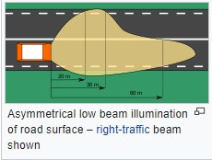

**Low beam of Car headlight**

High Beam is also called as main beam, driving beam, full beam that provides a bright, centre-weighted distribution

of light and it does not possess any control of light that are directed towards the other road user’s. High beam is only suitable for road with no other users, as the glare from the high beam may dazzle the other drivers.

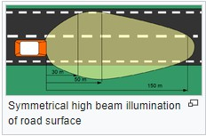

**RESULT AND ANALYSIS**

**Logic Results:**

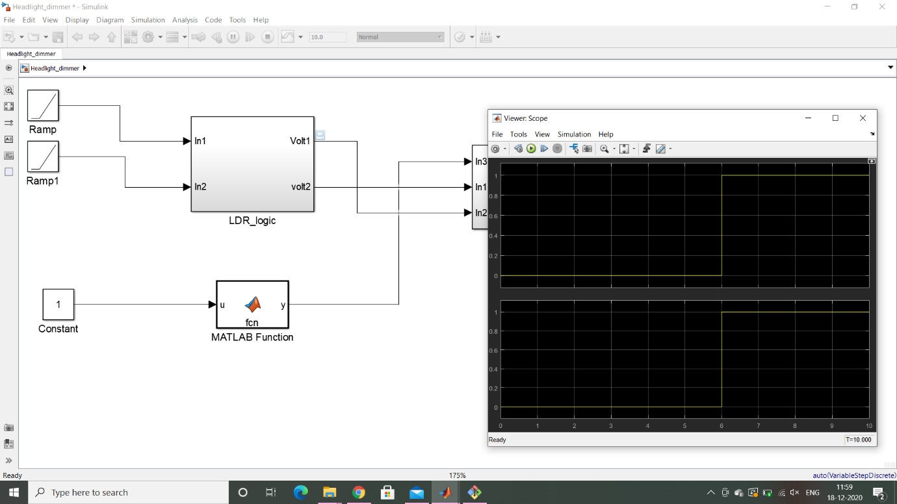

**Signal Builder Result:**

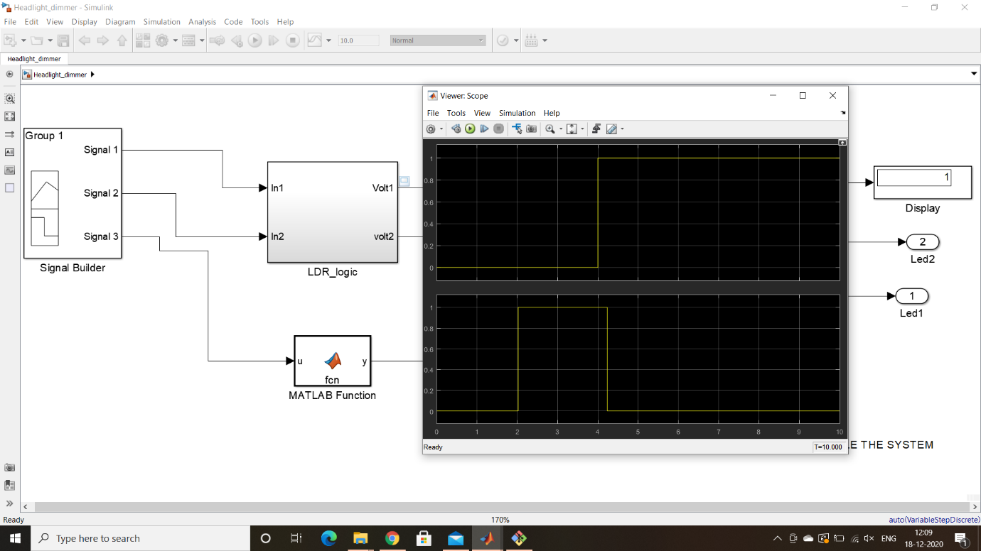

Simulation Switch Off:

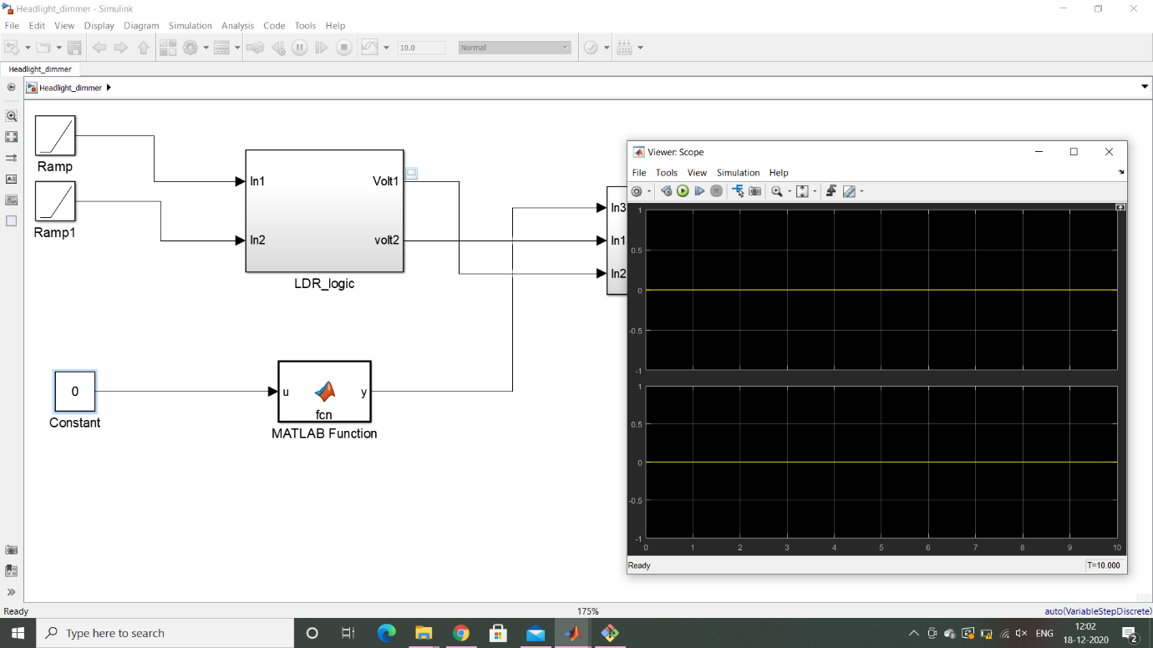

Data Inspector:

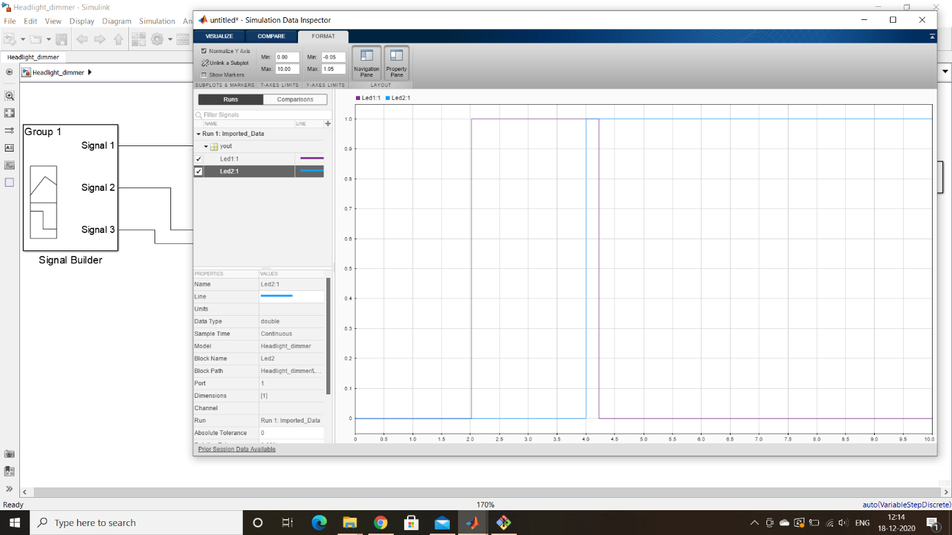

**CONCLUSION:**

This paper presents the automatic headlight dimmer that uses LDR. Here, high beam is automatically switched to low beam when a high beam of light from the another vehicle falls on the LDR. Glaring of light from the opposite vehicle during the night travel is one of the major problems. Though there is a manual method to reduce the headlight beam, it will be difficult during some situations.